Experiment 4: Image Restoration (Optional)

- Objective
(1) To know the concept of image restoration.
(2) To know basic function of image restoration in MATLAB
(3) To be able to evaluate different restoration methods and select the best one.

- Experiment Content

The following figures are one Saturn’s satellite--Helene’s images that have been taken by spacecraft Cassini. As you seen, they are degraded images in which there are some zebra strips caused by noise. Please try several methods to remove the strips from background to restore original images and evaluate your methods.

It is an open question. You are encouraged to try any methods to recover the degraded images.

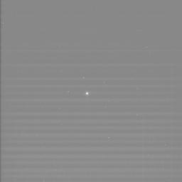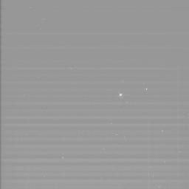
N1580854213_1.IMG N1848504927_1.IMG

- Some Possible Matlab functions
The functions that might be used in the experiment include fft2, ifft2, fftshift, ifftshift, fspecial，imnoise，conv2, deconv, deconvwnr, medfilt2, ordfilt2, imgaussfilt and so on. For more information, see the MATLAB HELP..

- Requirement of Experiment Report

In your experiment report, you should
1. Describe the experiment procedure
2. Give the original image and resulted image in your experiment.
3. Explain the reason why you select the method to recover the images.

